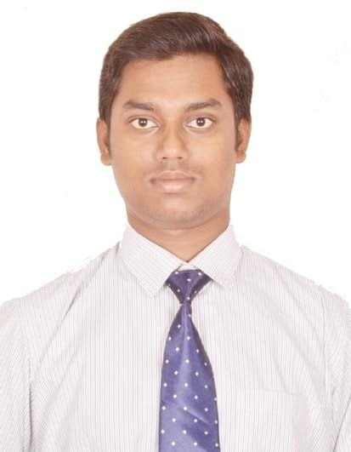­

+91 7008908416

g.sandeep.mohanty@gmail.com

**Sandeep Kumar Mohanty**

Experience Snapshot

* 4 years and 3 months of experience in Microservices development
* Hands on experience on J2EE; specifically Java Web-services (Jax-RS and Jax-WS)
* Hands on experience in creation of Microservices by using Spring Cloud and Spring Cloud Netflix
* Hands on experience in Spring Framework (Spring Core, Spring Mvc & Spring Data)
* Extensive experience in developing Rest Services and MicroServices
* Extensive work experience on SAFe Agile and Kanban
* Proven abilities as a problem-solver, troubleshooter and team player to achieve organizational goals

Profile Summary

* Oracle certified java programmer with over 4 years of experience in working in J2EE
* Proficient in creating Java web-services using both SOAP protocol and REST architecture
* Proficient in creating Spring Boot Rest and MicroServices
* Proficiency in Azure App-services, Azure Redis Cache, Azure Search, Pivotal Cloud foundry
* Hands on experience in front end framework like Angular 6 along with PrimeNG and VMware clarity
* Experience working on Version control Systems like Git, Bitbucket and RSA
* Extensive experience in unit testing web-services with Spring Test Suite
* Good knowledge on build engines like Maven and Gradle
* Worked on SAFe Agile software development environment and participated in various Agile ceremonies

Experience

|  |  |  |
| --- | --- | --- |
| **Company** | **Position** | **Job Duration** |
| Ernst & Young LLP | Consultant | December 2018 - Present |
| Tata Consultancy Services | Systems Engineer | September 2015- December 2018 |

Technical Skills

* Proficiency in Spring Boot Rest Services and Spring Boot MicroServices (Cloud Config Server, Feign, Service Registry, Circuit Breaker etc.)
* Deployment of Web application over Microsoft Azure platform and Pivotal Cloud Foundry
* Proficiency in Java, Microsoft SQL Database, MySQL database, IBM db2 database, JAVA Web Services, WebSphere Application Server, Splunk, WildFly application server
* Handling of tools like RSA, Eclipse, NetBeans, Rational Team Concert, Postman, Perfecto, Putty, SOAP UI, Splunk, Appdynamics, SiteScope, FireBase, Control-M
* Extensive working knowledge in domains such as Banking and Retail
* Successful completion of Certification in Oracle Certified Java Professional SE6 in 2016
* Was responsible for implementing Factory and chain of responsibility design pattern

Projects

* **JAVA** Developer for **Ernst & Young LLP**, with **DELL ARS** *as client* (**January 2019-Present**), **IT** Project based on **Kanban Squad** Methodology: *to develop Asset Resale Services Portfolio for DELL EMC Systems- which involved the development of a portal where the enterprise could Resale/Recycle/Sanitize their assets.*

|  |  |
| --- | --- |
| **Responsibilities** | * Design and Development of Pickup and Payment module * Design of cloud ready application with respect to. PCF; including deployment to & provisioning of PCF services. * Leading and mentoring the 5-member squad * Development of Writing Integration Test Suite with the help of Protractor * Integration with Subsystems like NOVORA and OnePCK |

* **JAVA** Developer for **Tata Consultancy Services Ltd.** with **Nielsen Corporation**, USA (**March 2018- November 2018**), **Retail** Project based on **Agile** Methodology: *to create backend API for Statistical dashboard which were the part of a novel project, by deploying the API over cloud network based on Microsoft Azure.*

|  |  |
| --- | --- |
| **Responsibilities** | * Development of the new Data and Selector API will form the backend for statistical dashboards developed on Angular * Design of the API network and Response Structure * Deployment of the Application over Azure app Service platform; including enablement of searching and facets option to selectors leveraging Azure Search Service * Creation of Dimensional metadata batch job to transfer data across various System of Records * Implementation in memory Redis cache for quicker retrieval of response |

* **JAVA** Developer for **Tata Consultancy Services Ltd.** with **United Services Automobile Association** (**July 2016-Februrary 2018**) - **Banking** Project based on **SAFe Agile** Methodology: *to replace legacy middleware with J2EE infrastructure by developing various Account Inquiry API*

|  |  |
| --- | --- |
| **Responsibilities** | * Development of the new Account Inquiry API to replace the legacy systems; including implementation of Enterprise piloting logic with 5-min backout capability for new API rollouts * Re-Designing the web bill pay enrolment process * Development of quality code by implementing java coding standards for every iteration; along with conducting unit testing of application code * Performance of value added stories in the iteration along with task stories * Performance of technical root cause analysis and outlines corrective action for given problems |

Achievements

* Awarded with **Kudos** for Designing and Delivering the Pickup Functionality with in limited time
* Won the **first prize in hackathon** organized by client for developing solution that will reduce manual processes
* Was awarded **Star of the month** for delivering two critical features within a month’s time
* Won **Best team award thrice** for showing extraordinary team management skills in API’s rollout